Guide for Finding Stuff in Salesforce,

Shortcuts and Reference Docs

Contents

Applications 2

Setup > App Manager 2

Objects 2

Setup > Object Manager 2

Setup > Schema Builder 2

UI Components 2

Lightning Components 2

Visualforce 3

Apex Classes 3

Unit Testing 3

SOQL and Data Queries 3

Security 4

Access Levels 4

Auditing 5

Manage Users 6

Roles 6

Profiles 6

Permission sets 6

Other Security Policies 6

# Applications

## Setup > App Manager

# Objects

## Setup > Object Manager

* [*Salesforce Help*: Object Relationships Overview](https://help.salesforce.com/articleView?id=overview_of_custom_object_relationships.htm&language=en_US)
* [*Salesforce Help*: Considerations for Relationship](https://help.salesforce.com/articleView?id=relationships_considerations.htm&language=en_US)
* [*Salesforce Help*: Design Your Own Data Model](https://help.salesforce.com/articleView?id=schema_builder.htm&language=en_US)

## Setup > Schema Builder

Shows the ERD

You can create objects here too

* [*Salesforce Help*: Schema Builder Custom Object Reference](https://help.salesforce.com/articleView?id=schema_builder_elements_objects_ref.htm&language=en_US)

# UI Components

## Lightning Components

Setup > Lightning Components

Or Open Developer Console

* [Lightning Aura Components Developer Guide](https://developer.salesforce.com/docs/atlas.en-us.224.0.lightning.meta/lightning/intro_framework.htm)
* [Lightning Web Components Developer Guide](https://developer.salesforce.com/docs/component-library/documentation/lwc)

## Visualforce

Developer Console >

* [Visualforce Developer Guide](https://developer.salesforce.com/docs/atlas.en-us.224.0.pages.meta/pages/pages_intro.htm)

# Apex Classes

* [Apex Developer Guide](https://developer.salesforce.com/docs/atlas.en-us.224.0.apexcode.meta/apexcode/)

# Unit Testing

# SOQL and Data Queries

# Security

* [Security Implementation Guide](https://developer.salesforce.com/docs/atlas.en-us.224.0.securityImplGuide.meta/securityImplGuide/)
* [Licenses Overview](https://help.salesforce.com/HTViewHelpDoc?id=users_licenses_overview.htm&language=en_US)
* [Control Login Access](https://help.salesforce.com/apex/HTViewHelpDoc?id=controlling_login_access.htm&language=en_US)
* [Set Login Restrictions](https://help.salesforce.com/HTViewHelpDoc?id=admin_loginrestrict.htm&language=en_US)
* [Delegate Administrative Duties](https://help.salesforce.com/HTViewHelpDoc?id=admin_delegate.htm&language=en_US)
* [Salesforce Security Guide](https://developer.salesforce.com/docs/atlas.en-us.securityImplGuide.meta/securityImplGuide/login_ip_ranges.htm)
* [Controlling Access Using Hierarchies](https://help.salesforce.com/HTViewHelpDoc?id=security_controlling_access_using_hierarchies.htm&language=en_US)

Also:

[Apex Sharing](https://help.salesforce.com/HTViewHelpDoc?id=security_apex_sharing_reasons.htm&language=en_US).

## Access Levels

Data Access Levels:

* Objects
* Fields
* Records

Control Levels:

* Organization wide defaults (can add more fine-grained features on top of these)
* Role hierarchies – shared access across groups of users
* Sharing rules – open up access on an exception basis (1 user in the role needs to see x..)
* Manual sharing – owners of specific records can share them with other users (ie. Vaca backup)

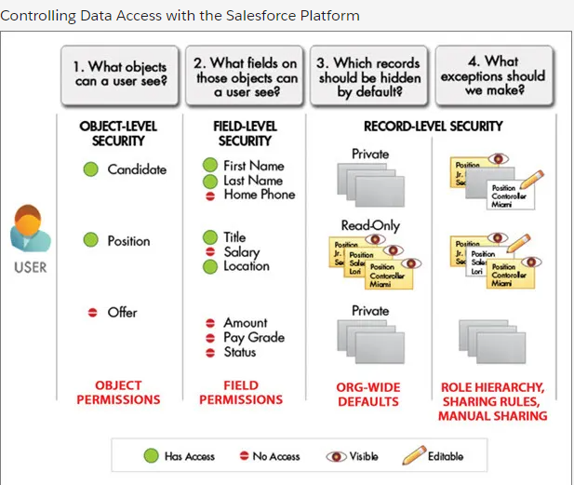

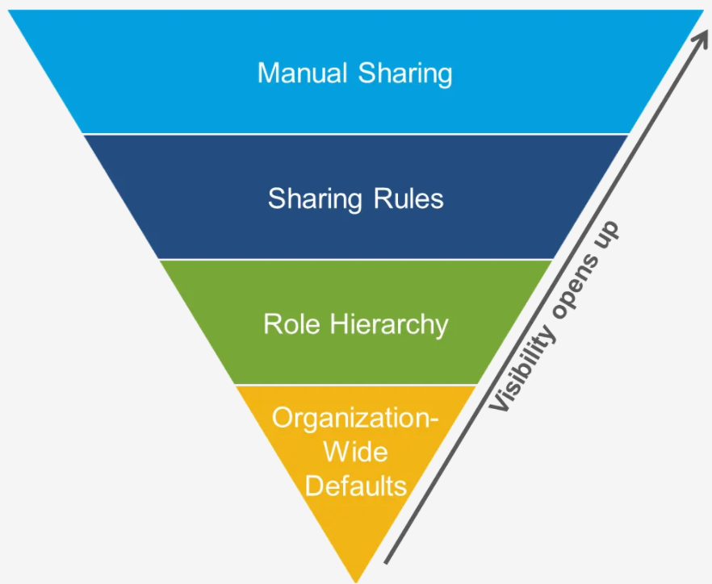

## Auditing

Options include field history, login history, etc…

[Login History](https://help.salesforce.com/HTViewHelpDoc?id=users_login_history.htm&language=en_US).

[Monitor Setup Changes](https://help.salesforce.com/HTViewHelpDoc?id=admin_monitorsetup.htm&language=en_US).

[Field History Tracking](https://help.salesforce.com/HTViewHelpDoc?id=tracking_field_history.htm&language=en_US)

[Monitor Login History](https://help.salesforce.com/HTViewHelpDoc?id=users_login_history.htm&language=en_US).

## Manage Users

Setup > Users

The license determines which profiles are available

## Roles

Setup > Roles

## Profiles

Setup > Profiles

Setup > User Management Settings > Enhanced Profile User Interface

Definition for a type of User (ie Admin)

Controls access to Apps, license

Enhanced Profile Interface allows you to clone an existing profile

You can assign profiles to Permission sets

You can define field level permissions here under Object Settings > Field Permissions

Manage Assignments – this is where you select users who require this profile

* [Profiles](https://help.salesforce.com/s/articleView?id=sf.admin_userprofiles.htm)
* [Viewing Profile Lists](https://help.salesforce.com/HTViewHelpDoc?id=users_profiles_view.htm&language=en_US)
* [Edit Object Permissions in Profiles](https://help.salesforce.com/HTViewHelpDoc?id=perm_sets_object_perms_edit.htm&language=en_US)
* [Enable the Enhanced Profile View Interface](https://help.salesforce.com/HTViewHelpDoc?id=users_profiles_about_enhanced_ui.htm&language=en_US)
* [Field-Level Security](https://help.salesforce.com/s/articleView?id=sf.admin_fls.htm)

## Permission sets

Setup > Profiles

Grant additional permissions to specific users on top of existing profile permissions

* [Permission Sets](https://help.salesforce.com/s/articleView?id=sf.perm_sets_overview.htm)
* [Considerations for Permission Sets](https://help.salesforce.com/HTViewHelpDoc?id=perm_sets_considerations.htm&language=en_US)

## Other Security Policies

IP Ranges: Setup > Network Access

Password Policies

Profiles (restrict login access by IP or time)

Before creating sharing rules create a Public Group (Setup > Public Groups)

Setup > Sharing Settings

* [Sharing Settings](https://help.salesforce.com/s/articleView?id=sf.managing_the_sharing_model.htm)
* [Sharing Considerations](https://help.salesforce.com/apex/HTViewHelpDoc?id=security_sharing_considerations.htm&language=en_US)
* [Organization-Wide Sharing Defaults](https://help.salesforce.com/s/articleView?id=sf.security_sharing_owd_about.htm)
* [Sharing Rules](https://help.salesforce.com/apex/HTViewHelpDoc?id=security_about_sharing_rules.htm&language=en_US)
* [Sharing Rule Categories](https://help.salesforce.com/HTViewHelpDoc?id=security_sharing_data_set_categories.htm&language=en_US)
* [Sharing Considerations](https://help.salesforce.com/apex/HTViewHelpDoc?id=security_sharing_considerations.htm&language=en_US)